In You I Am Well Pleased
August 27, 2017

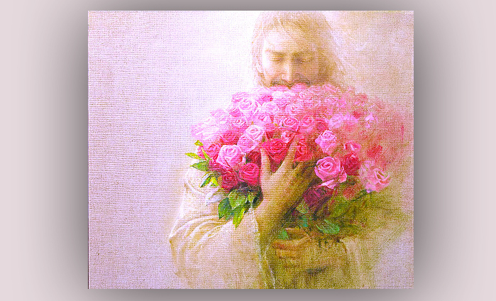
May these words of praise and encouragement truly lodge themselves in your hearts, faithful brides.

After communion, Jesus immediately said to me, “I want to write a letter to My Bride."

He began, “My Beloved Bride, I am here for you, always with you, always guiding you. Though you are not aware many times of My voice, you have an impulse to do something and you move on that. Many times that is Me, requesting favors of you. You just don’t realize it. Many of you have very supple hearts. Hearts that are tuned into My wishes. Through you, I do unthinkably amazing things without your knowledge.

"It is your great love for Me, your great desire to please Me, that motivates your every decision and even the slightest movements. To you, I am eternally grateful, because you bring Me the consolation I have so been needing. Please, no matter how difficult or discouraged you may feel, do not give up on this practice of doing the little things for Me, for Love of Me.

"Yes, the little things lead to the bigger things. I know many of you have suppressed thoughts of ambition and gaining influence among men. Though it would not be difficult for you to have this kind of influence in your circle of friends, you have shunned it out of fear of pride and vanity. In this, My Bride, you have listened very carefully to Me and set your heart on Me alone - as well as avoiding many, many pitfalls of the enemy, traps set for you along that kind of trail.

"You have sold all your agendas to the world to buy this one precious pearl: the Happiness of My Heart.

"How can I thank you? A thousand times over, I shall never be able to thank you. But I do wish for you to know that you are on the right track. You are pleasing to Me, and in this dark and dreary world, each of you are My sunshine. You cannot even begin to fathom what I have prepared for you on the other side, when you come to live with Me in Heaven. Suffice it to say, you will never grow weary or discouraged again. The deepest longings of your heart will be satisfied and you will live in continual joy and bliss, even though at times you will grieve for your fellows on Earth.

"I want you to know that your littleness is making the difference in this world. Even in the world of My church and its structures, where there are sometimes endless agendas of promotion and recognition, vying for influence, posturing, and gaining influence and control. I hate this, and I must see it every day in My Body.

"What I want to say, is that your commitment to this littleness brings Me unspeakable joy and even bliss, because you have chosen the better part.

"Oh dear ones, never do anything out of a desire to please men or to receive their applause. So treacherous are the ways of Satan, and through this attitude many are hooked and dragged down to a fall. They lose My company and the sweetness We enjoyed in the gardens of their hearts.

"They wanted the world, influence, money—more, more, more of the things of the world—so they chose the political life within the church to accumulate wealth and fame. How beautiful is your littleness beside these creatures made in My image, who have turned into grotesque monsters through their toxic desire natures. Do not be fooled by this lifestyle. You are truly My sunshine in this world and Satan despises your choice to honor Me.

"If you gain promotions, if doors are opened for you, BEWARE. Not all is as it seems. Do not grow dependent on anything or anyone but Me. Many times it seems harmless to enjoy the perks these positions hold and the enemy very surreptitiously draws you into his schemes to become dependent on anything outside of yourself. Anything. Anything outside of yourself and your relationship with me is very dangerous. Never become dependent on anything or anyone other than me.

"Always be ready to renounce this position if you are being led to compromise. Be ready to step down and to keep your relationship with Me safe, rather than to follow these things and give in to compromise—will be your undoing. Better to be without, than to get what you want through compromising what you believe I am calling you to, what you believe I am teaching you and what you know in your heart of hearts is right. Continue in this uncompromising life style and you will continue to be My sunshine.

"Satan hates what you have. He hates your humility. He hates your conversations with Me. He hates your worship of Me and his whole life agenda is to take these things from you. So beware.

"In the meantime, spread the joy and peace of having Me as your Lord and forsaking the emptiness of the world. Guard our trysting time with unyielding vigilance, so that you do not grow weak or lukewarm and fall away from Me.

"Remember, My Brides, you are My sunshine; you are My light in the darkness of this world. And you are greatly feared by the kingdom of darkness. Your angels far outweigh anything the enemy has and have no fear of taking authority and routing the enemy.

"You are My forever Love; in you I am well pleased."

